IMPORTANT NOTES REGARDING PLACEMENTS:

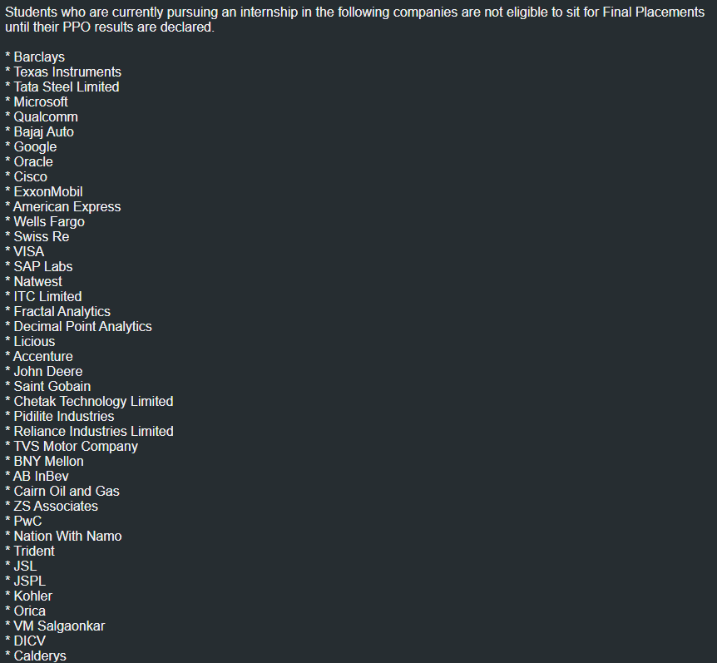



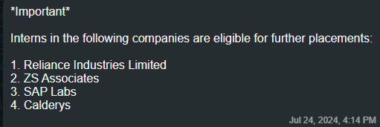

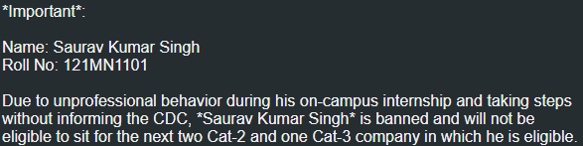

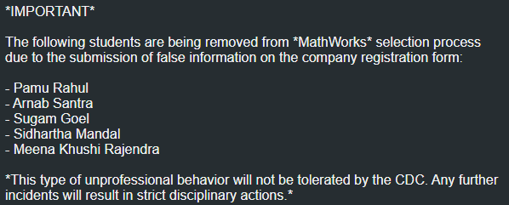

0 Selection Companies :

1. Increff
2. ProcDNA
3. BitGo
4. Licious SDE PPO Res.
5. Apple
6. Idrive
7. Sigmoid Analytics
8. WriteSonic
9. Atlas
10. Datoms(Embedded Software Engg.)
11. Leap
12. Infosys (Specialist Programmer)
13. Pubmatic
14. Whiteklay
15. BlackNgreen
16. Nation with Namo
17. Zanskar Technologies
18. Sigmoid (Data Engg. – 0 Recruits , )
19. Aira Matrix Pvt. Ltd.
20. ScoreMe Solutions
21. TCS (R&I)
22. Cimpress India
23. Fischer Jordan (SWE) : 0 CV shortlists
24. Saviynt : 0 OT shortlists
25. NVIDIA (Software Compiler Verification )
26. Restroworks
27. GreyOrange
28. NVIDIA (System Software Intern )
29. Squadcast
30. Larkai Healthcare
31. Swiggy
32. Tracelink
33. Thorogood Associates
34. CloudEagle.ai (0 CV Shortlists)
35. Digio
36. SIXT Research & Development India
37. Osfin.ai (Data analyst)
38. KPIT
39. D. E. Shaw

PSU’s :

1. BPCL

PWD:

* + - 1. TVS MOTOR COMPANY
      2. Schneider Electric

Female Only Companies :

1. Warner Bros. Discovery
2. Tesco (Code Her challenge)
3. IBM Software Labs
4. Nvidia LLVM Compiler Intern

International Offers :

* + - 1. Varuna Marine Services (*CTC:* EURO 32412, FTE : Netherlands)

Bond :

1. Sigmoid Analytics (2yrs)
2. Dassault Systemes (Fresher’s Bond of Rs. 100,000/- (Bond period: 18 months) )
3. AiraMatrix (2Yrs)
4. Unistring Tech Solutions (1 yr)
5. Tescra Software (2 yrs)
6. iServeU (2 yrs)
7. Mckinley Rice(18 Months)
8. FischerJordan(Data Analyst, SWE , Full time Web Developer) 3 years
9. LUMIQ.AI: Minimum period of 18 months post confirmation
10. Larkai Healthcare : 1yr
11. (TCE )Tata Consulting Engineers (36 Months , 50K bond amount)
12. FIITJEE (3yrs)
13. PhysicsWallah (1 yr)
14. AIHIFusion Technologies (1 yr)

Remote :

1. Writesonic Private Limited
2. Quicksell
3. MPL (Immedieate Joining)
4. Trilogy Innovations
5. Cimpress India
6. FINTECH GLOBAL CENTER PRIVATE LIMITED
7. Mantra Softech
8. Mewurk Technologies
9. Intandem
10. HealthWorksAI
11. Turing
12. CloudEagle.ai
13. Octet Consultation
14. Wokelo.ai

Companies that revisited for different roles in Same year :

1. TCS :

1. NQT

2. Research & Innovation

3. Tata Consulting Engineers (TCE)

1. IBM :
   1. Systems
   2. Software Labs
2. Siemens :
   1. EDA
   2. Healtineers
   3. Technology
3. Searce Inc. :
   1. Software Roles (8)
   2. Analyst roles (3)
4. Infosys :
   1. Specialist Programmer
   2. Systems Engineer
5. Datoms :
   1. UI UX Role
   2. Embedded Firmware Intern
   3. Data Analyst
6. Quantum Street AI :
   1. Associate Software Engineer
   2. Associate Data Scientist
7. Warner Bros. Discovery :
   1. SWE Intern (Female)
   2. SWE-1(Female)
8. Nvidia :
   1. Software Compiler Verification Intern
   2. Hardware Engineering Intern
   3. LLVM Compiler Intern (Female only)
9. Fischer Jordan
   1. SWE/ Full Time Web Developer
   2. Data analyst
10. KickDrum
    1. Software Developer (6M+FTE)
    2. Software Developer (6M+PPO)
11. Accenture
    1. AI Specialist , Senior Analyst & Analyst
    2. Adavacned Application Engg. Analyst
12. STMicroelectronics
    1. Software Intern
    2. Hardware Intern
13. Convin :
    1. (SDE 1,Associate Implementation Consultant)
    2. Associate Implementation Consultant
14. RAAM Group
    1. Next Gen leader
    2. Management Trainee
15. QuickSell :
    1. Frontend , Backend Engg.
    2. iOS Developer
16. Bajaj :
    1. Bajaj Auto Credit Ltd. (graduate trainee)
    2. Bajaj Auto Ltd. (graduate trainee)
17. Nation With Namo :
    1. Decision Scientist (AnC)
    2. Product Associate & SDE (Software role)
18. Tredence Analytics :
    1. Analyst Data Scinence (12LPA, Btech only)
    2. Analyst(10 LPA)
19. L&T :
    1. GET,PGET
    2. SAME ROLE
20. Simplotel
    1. Digital Marketing Manager, Backend Developer
    2. Customer Success Manager

Hackathons :

1. Cisco : Women in Technology
2. Energy Transition Hackathon | Mercuria India
3. *GreyB Open Innovation Challenge | Workshop* _GreyB is a Singapore-based innovation consulting firm specializing in custom analysis of patents, research papers, and market reports to deliver insights.
4. TELIPORT Season 2 I Tata Elxsi
5. INNOVERSITÉ - BNP Paribas
6. *ACCENTURE | Tech Thrivers 2024 | Online Event* *Eligibility:* Only female Candidates
7. Myntra | HackerRamp: WeForShe 2024
8. Amazon WoW (Women of the World) | Amazon | Mentorship Program
9. Myntra | ShE-roes Unplugged
10. Adobe GenSolve - Innovate to Impact
11. i.mobilothon 4.0 | Volkswagen Group Technology Solutions India

CS Only Companies :

* + - 1. MAQ Software
      2. GEP Worldwide
      3. Warner Bros. Discovery
      4. SunTec Business Solutions
      5. Exotel
      6. SIXT Research & Development India
      7. Wokelo.ai
      8. Siemens Healthineers

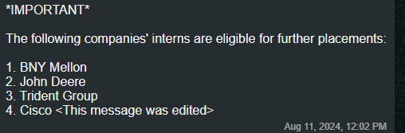

TCS ALLOWS 1 BACKLOG

BITGO REVISED THEIR CGPA FROM 7.5 TO 7

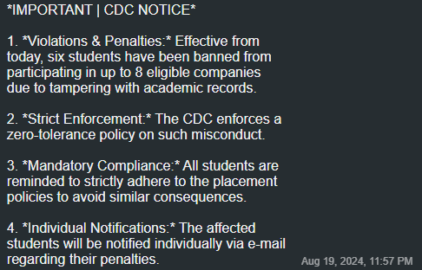

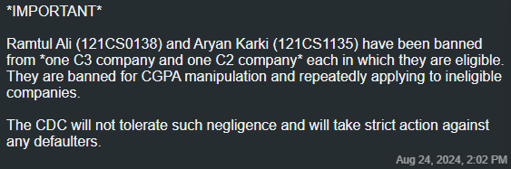

QuickSell Location : Remote (For the 6 Months Internship Period) ,after PPO Confirmation location will be Mumbai)

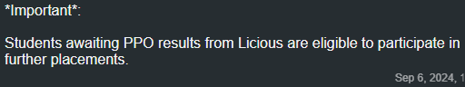

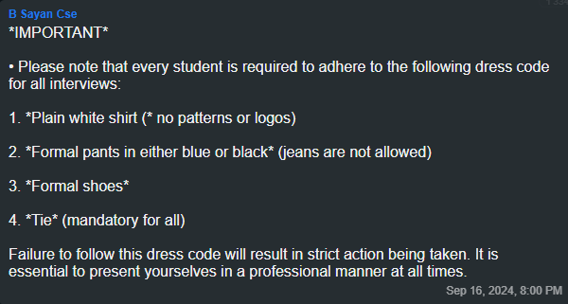

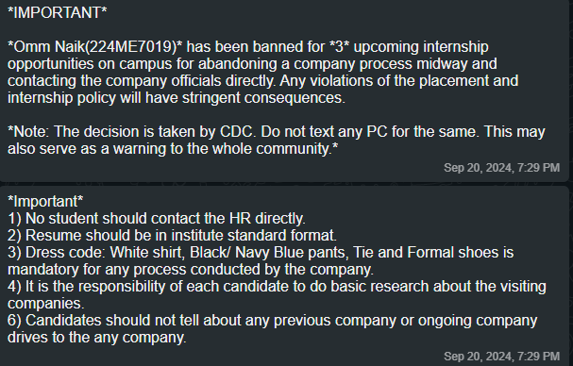

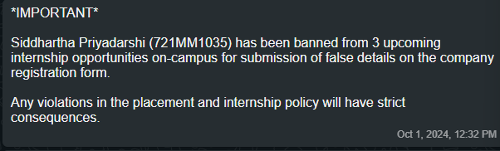

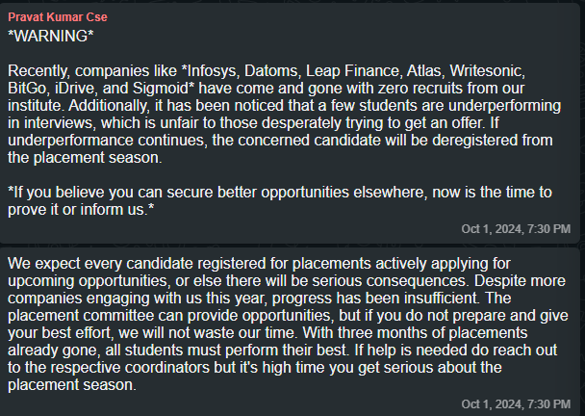

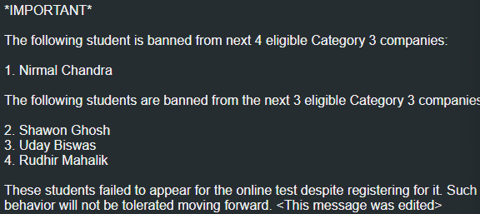

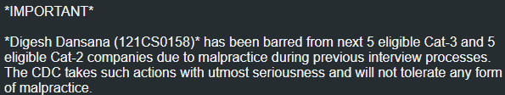

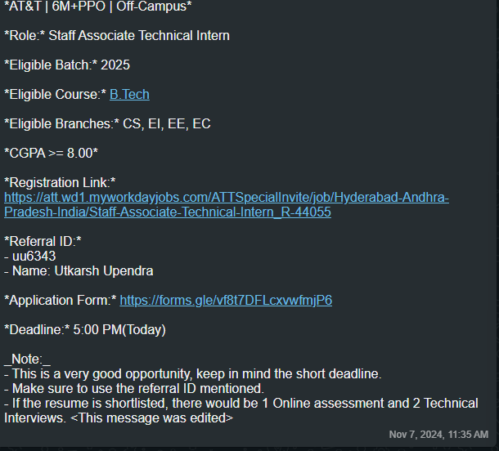

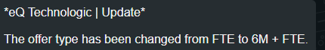

Offer type of GEP Worldwide , GE Healthcare and eQ Technologic is changed from FTE to 6M+FTE

